PV AND PVC in MASTER NODE ARCHITECTURE (USING NFS)

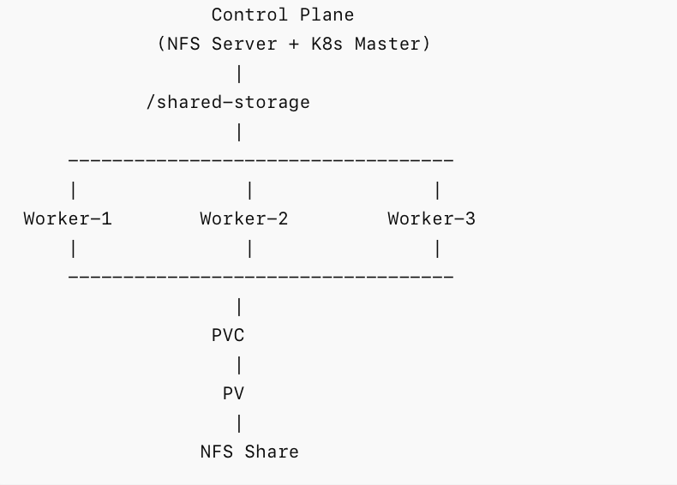



Step 1: Install NFS Server on Control Plane
SSH into Control Plane.
sudo apt update
sudo apt install nfs-kernel-server -y

Verify:
systemctl status nfs-kernel-server

Step 2: Create Shared Directory

sudo mkdir -p /shared-storage
sudo chmod 777 /shared-storage
Create a test file:
echo "Welcome to Shared Storage" | sudo tee /shared-storage/index.html

Verify:

ls -l /shared-storage

Step 3: Configure NFS Export

sudo nano /etc/exports

Add:
/shared-storage *(rw,sync,no_subtree_check,no_root_squash)

Save and exit
Apply exports:
sudo exportfs -ra

Verify:

sudo exportfs -v

Expected: /shared-storage

Step 4: Install NFS Client on All Worker Nodes
Run on Worker-1, Worker-2, Worker-3:

sudo apt update
sudo apt install nfs-common -y

Step 5: Test Mount Manually
copy Control Plane IP (private ip)
On worker node:
sudo mkdir /test-nfs
sudo mount 192.168.1.100:/shared-storage /test-nfs
#here replace 192.168.1.100 with the private ip of the control plane
Verify:
ls -l /test-nfs
expected: index.html
Unmount:
sudo umount /test-nfs

Step 6: Create Persistent Volume
Create file:

vi nfs-pv.yaml

Check from https://github.com/letslearn207/kubernetes/blob/main/c9/pv.yml

#replace : CONTROL_PLANE_IP

kubectl apply -f nfs-pv.yaml

Verify:
kubectl get pv
Expected:
nfs-pv Available

Step 7: Create PVC

vi nfs-pvc.yaml

https://github.com/letslearn207/kubernetes/blob/main/c9/pvc.yml

kubectl apply -f nfs-pvc.yaml

Verify:
kubectl get pvc

Expected: bound
Step 8: Verify binding

kubectl get pv
kubectl get pvc

Expected:
PV = Bound
PVC = Bound
Step 9: Create first pod
vi pod1.yaml
https://github.com/letslearn207/kubernetes/blob/main/c9/pod1.yml

kubectl apply -f pod1.yaml

Step 10: Write data
kubectl exec -it pod1 -- bash
Create file:
echo "Hello From Pod1" > /usr/share/nginx/html/demo.txt

verify:
cat /usr/share/nginx/html/demo.txt

exit

Step 11: Verify on Control Plane

cat /shared-storage/demo.txt

Expected: Hello From Pod1
Step 12: Create Second Pod

vi pod2.yaml

https://github.com/letslearn207/kubernetes/blob/main/c9/pod2.yml

kubectl apply -f pod2.yaml

Read the Data from pod2:
kubectl exec -it pod2 -- bash
cat /usr/share/nginx/html/demo.txt

o/p: Hello From Pod1

This proves shared storage

Step 14: Check Node Placement
kubectl get pods -o wide
Example:
pod1 Worker-1
pod2 Worker-3
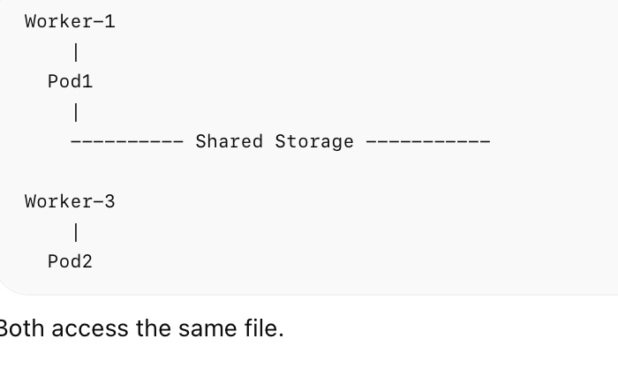


Step 15: Data Persistence Test

kubectl delete pod pod1
Verify if the file still exist:
kubectl exec -it pod2 -- cat /usr/share/nginx/html/demo.txt
Expected:
Hello From Pod1
Step 16: Create Deployment Using PVC

https://github.com/letslearn207/kubernetes/blob/main/c9/deployment.yml

kubectl apply -f deployment.yaml
kubectl get pods -o wide

